CSCI 260

Professor Dey

Homework 4

Q) MIPS basic instructions: LUI, JAL, JR, LB, SB, MFLO, SLTI

**Solation**

|  |  |  |  |  |
| --- | --- | --- | --- | --- |
| Operation | Meaning | Type | Opcode | Function |
| LUI | Load Upper Immediate | I | 0x0f | NA |
| JAL | Jump and Link | J | 0x03 | NA |
| JR | Jump to Adder in Register | R | 0x00 | 0x08 |
| LB | Load Byte | - | - | - |
| SB | Store Byte | I | 0x28 | NA |
| MFLO | Move from Low Register | R | 0x00 | 0x12 |
| SLTI | Set to 1 if Less Than | R | 0x00 | 0x2A |

LUI

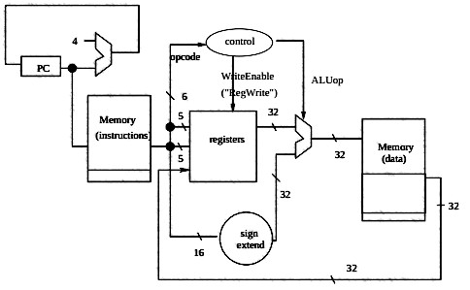

JAL

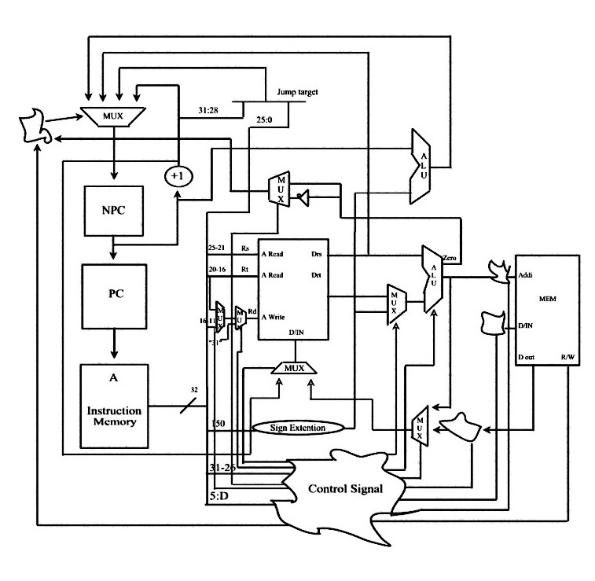

JR

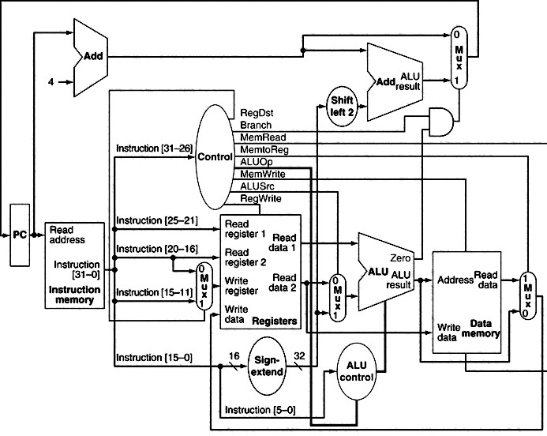

LB

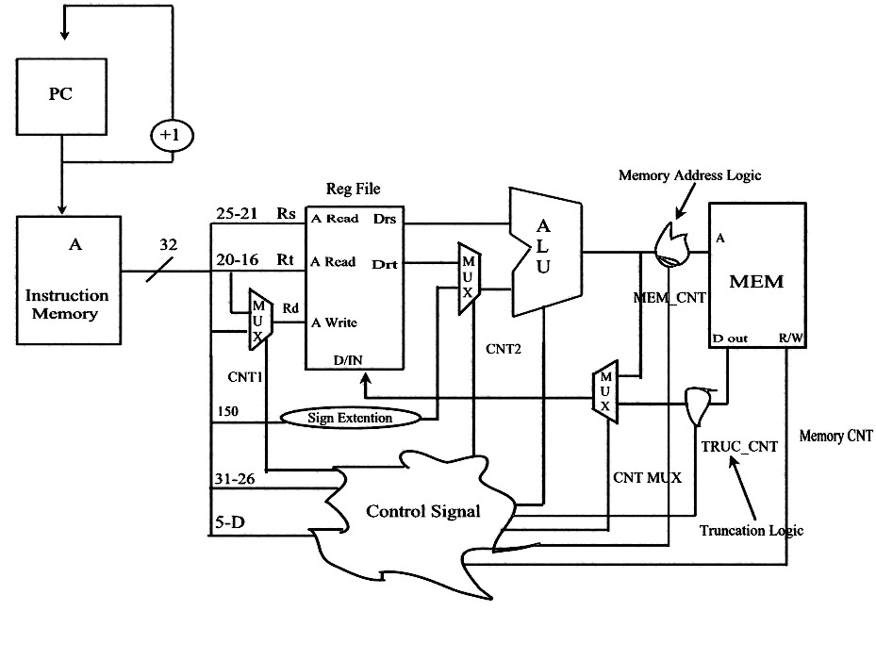

SB

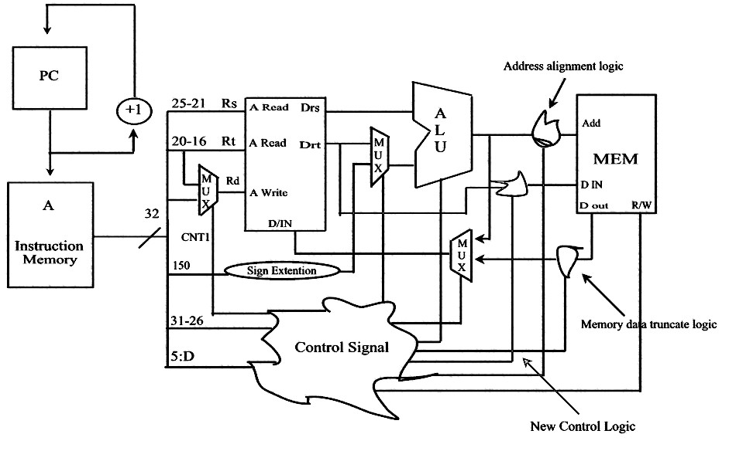

MFLO

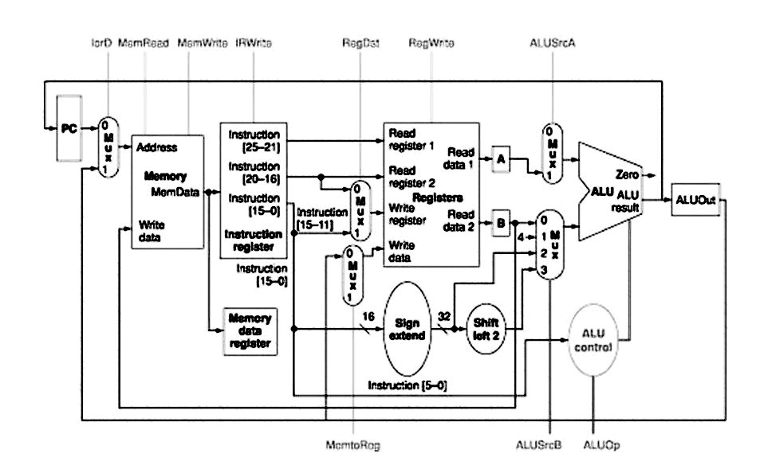

SLTI

